

**AITEL EXAMINATIONS BOARD**

**END OF TERM 1ITEM ASSESSMENT 2024**

**S.3 PHYSICS**

**PAPER 1**

**2 Hours**

**INSTRUCTIONS**

* Attempt any four items in this paper.
* Use only the answer booklets provided to answer the items.
* Where necessary, assume 𝑔𝑔 = 10𝑚s−2.
* Each item is 20 scores
* Density of air is 1.3 kg/m3
* Density of water is 1000 kg/m3

**1. Scenario**

A boy was travelling with her parents by means of water transport. He carried a ball and a phone taking selfies along the journey. On their way water waves disturbed the boat and all he had on his hands dropped in water. However, with much disappointment of loosing his phone, all over sudden he realised the ball was still on top of water though phone was no where to be seen. This scene left them wondering the magic with the ball. As they continued they looked in the air and saw two people seated in a bucket connected to a balloon with burning flame was carrying them in space. The boy was confused and wondered how the two men would land safely on the ground though his parents couldn’t explain anything to him.

**Support information**

*Take the density of water =1000 kg/m3*

*Acceleration due to gravity = 10 ms-2*

*Mass of the boat = 200 kg*

*Mass of a phone = 500 g*

*Volume of a phone = 50 cm3*

*Volume of a ball = 20 cm3*

*Volume of the boat = 3000 cm3*

***Task:***

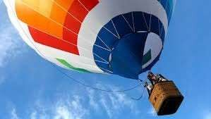As a Physics learner, help the boy understand what happened while on the boat and also explain for him how the two heavy men were being carried by just a balloon with burning air.

**2.**

Of recent, a story building being constructed in Kampala near Munyonyo collapsed and took very many lives. However, when police arrested the contractor and asked the cause of the collapse, he complained that the client didn’t give enough money to buy the appropriate materials for constructing the building given that the place is affected much by harsh weather conditions. However, when the KCCA Engineer was tasked to analyse the situation, he said “the *mechanical properties of the materials being used are below the standard required for a story building near such areas. He said young’s modulus of steel should be about 2x1011 N/m2*”. This statement confused the public the more.

**Support material**

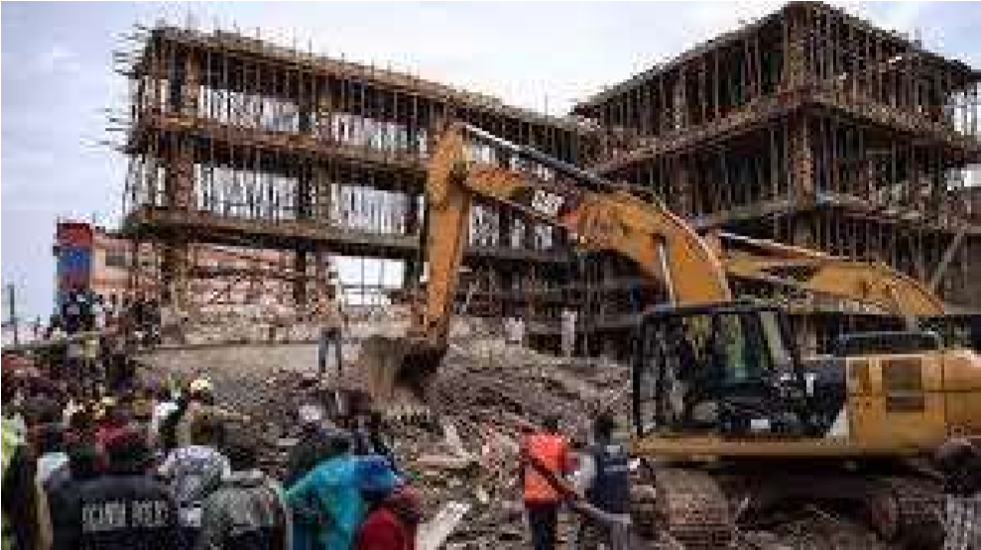

A force of 500 N causes an extension of 20 mm on an iron bar of length 100cm whose cross-sectional area is 0.05 cm2.

**Task**

As a learner of Physics, you have been asked by police to produce a report about the scene to help the police carry out investigation on the contractor.

**3. Scenario**

Two people stood in the middle of a disco hall at an un known distance between them. The woman calls the boy and she hear her self 5 seconds later while the boy hears the second sound after 4.5 seconds. The two discovered that their sound was clearer at night than during the day. While in the hall their blue and yellow clothes had changed in colour as a result of the disco lights. These scenarios left them confused and disturbed without understanding the magic in the hall.

**Support material**



**Task**

As a learner of Physics, help the two people analyse and understand what happened to them.

**4.**

A uniform metallic rod of length 4.0 m pivoted at its centre is used at a children’s play resort. If a boy of mass 48 kg sits 1.5 m from one end. Another boy of mass 40 kg wants to seat at a distance of 0.6 m from the centre on the other end to balance with the boy at the other end. **Support material**

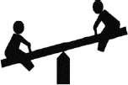

**Task**

Help the guide at the play resort to direct the learners on how to play the game safely. Also analyse what would happen to the beam if one end of the rod was heated by a considerably hot flame when the boys are off the simple machine so that safety is ensured during plays.

**5. Scenario**

On November 7th ,2022, Uganda as a country launched its first satellite named Pearl Africa Sat-1 into space with the support from NASA. One of the purposes of the launch was to study weather patterns to help farmers. On the other hand, data collected from the satellite showed that while in Uganda was day time, it was night time in the USA. And also, Europe was experiencing winter season while Uganda was receiving normal weather changes. The teacher told learners that “*there is a lot of information and purposes that the satellite can provide* “but the students couldn’t understand and believe the teacher.

**Support material**

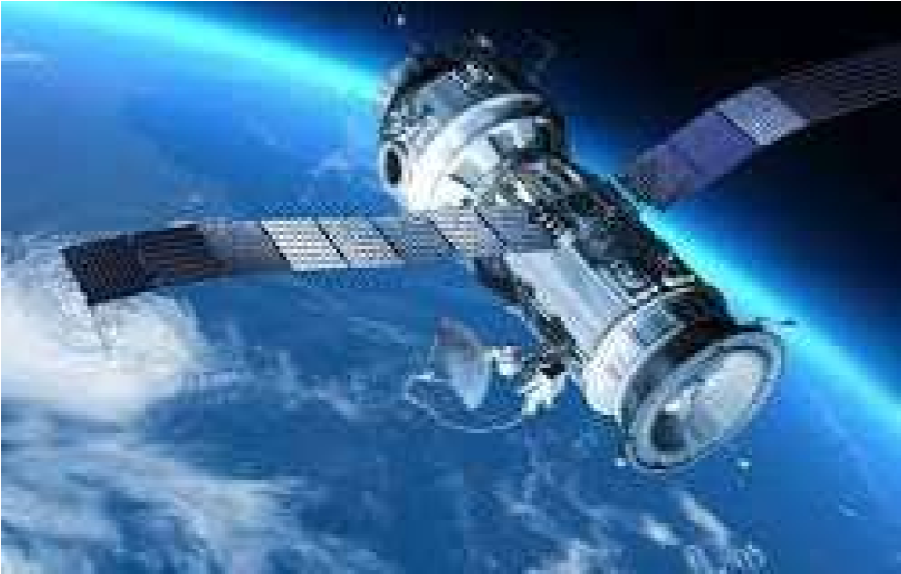

**Task**

As a learner of Physics, write an article to be published over the news paper to educate the public about changes in time, seasons and all the major purposes of an artificial satellite.

**6.**

In a certain town, it is a must for drivers to be tested with their vehicles for road-worthiness. On a certain day, a car started from rest and accelerated to 50 ms-1 in 10 seconds. The driver maintained that velocity for 20 seconds and suddenly decelerated to rest in 2 seconds causing him to crush into windscreen. As a result, the car tyres wore out on the tarmac causing a lot of heat on the ground. **Support material**

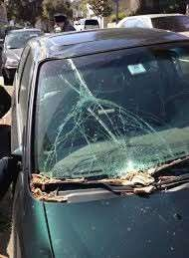

**Task**

You have been tasked to write a report to explain the scene. In your report include a motion graph, Find the rate at which the car’s velocity reduces and explain why driver crushed into the wind screen. Advise by stating whether the drivers average speed exceeded the speed limit of 8 ms-1 and how he would prevent the crushing.

**END**